Stratus ODI version 1.16 is pending in the Apple Store

The next release of the Stratus ODI has been sent to the Apple store and is expected to be released in the next two weeks.

Release Content

Version 1.16 fixes a significant issue with iOS 9 - the external speaker not being recognized by the application. With Version 1.16, if a speaker is plugged in, it is recognized and the output of the iPad is routed to the external speaker.

Version 1.16 includes an enhancement to the language screen to eighteen (18) buttons per page. The Stratus ODI will use the current address book and display the first sev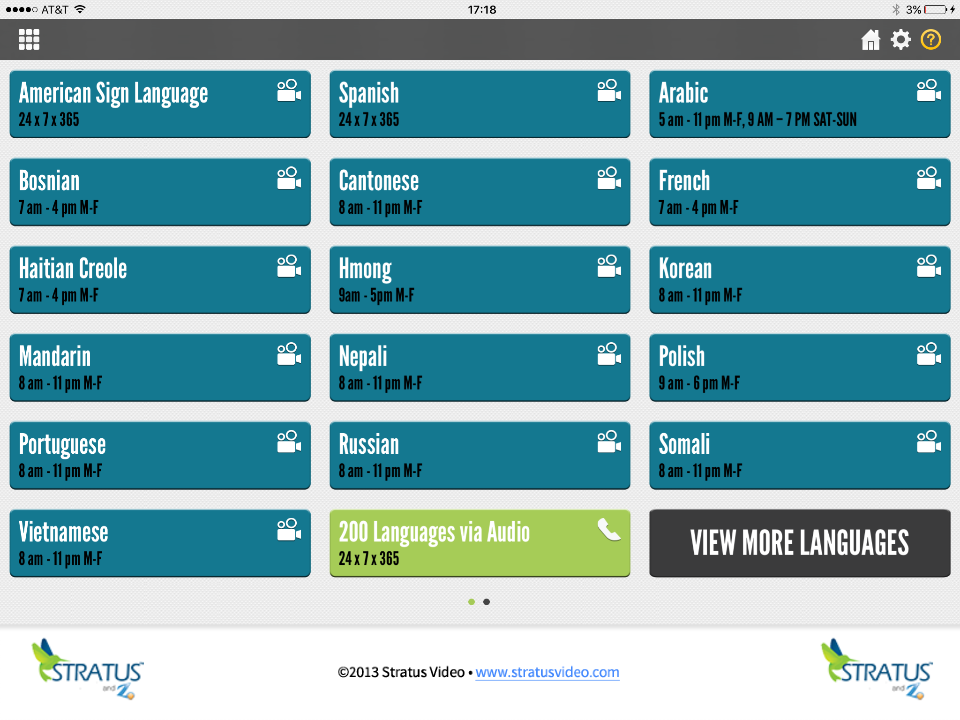enteen (17) languages in the address book on the first page. The eighteen button is reserved for the “View More Languages” button. Here is a screen shot of what it looks like:

The buttons are slightly less in height and still have two lines for language and schedule.

This has been a highly requested feature to have more languages per page so we took advantage of the requirement to fix the speaker issue to add the expanded language screen.

The App is set to become available in the apple store as soon as it is approved. A notice will be sent to the field as soon as it is “published” in the store.